Cell Analogies

Complete the following table by looking at the picture or name of each organelle. List the name of each organelle and its function in the appropriate column in the table.

Eukaryotic Cells

Picture | Organelle | Analogy
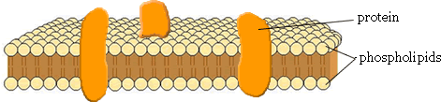


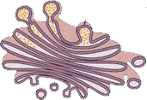
 | Vesicles
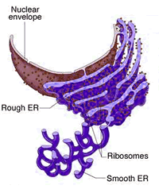 | Ribosome
 | Rough ER
 | Smooth ER
 | Lysosome
 | Nucleus
 | Nuclear Membrane
 | Cell wall
 | Cytoplasm

